**User:**

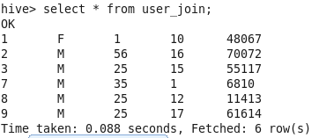

**Rating:**

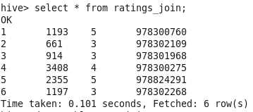

**Movies:**

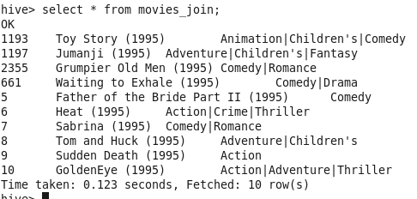

**Right outer Joins:**

Right-outer joins return all records in the right-hand table that match the WHERE clause. NULL is used for fields of missing records in the left-hand table.

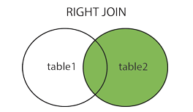

**Right-Outer Join:**

SELECT * FROM ratings_join r RIGHT OUTER JOIN user_join u ON r.userid = u.userid;

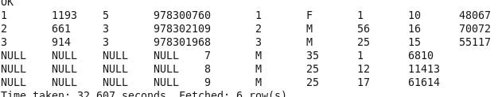

**Right-Outer Join without where clause and userid from left table:**

SELECT r.userid, r.movieid, r.rating, u.Gender, u.Age, u.Occupation FROM ratings_join r RIGHT OUTER JOIN user_join u ON r.userid = u.userid;

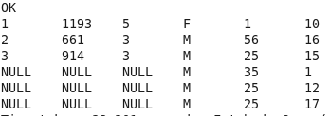

**Right-Outer Join without where clause and userid from right table:**

SELECT u.userid, r.movieid, r.rating, u.Gender, u.Age, u.Occupation FROM ratings_join r RIGHT OUTER JOIN user_join u ON r.userid = u.userid;

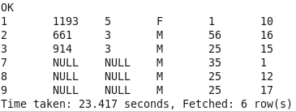

**Right -Outer Join without on clause:**

SELECT u.userid, r.userid, r.movieid, r.rating, u.Gender, u.Age, u.Occupation FROM ratings_join r RIGHT OUTER JOIN user_join u where r.userid = 3;

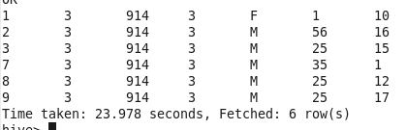

**Right -Outer Join without on clause and where clause:**

SELECT u.userid, r.movieid, r.rating, u.Gender, u.Age, u.Occupation FROM ratings_join r RIGHT OUTER JOIN user_join u;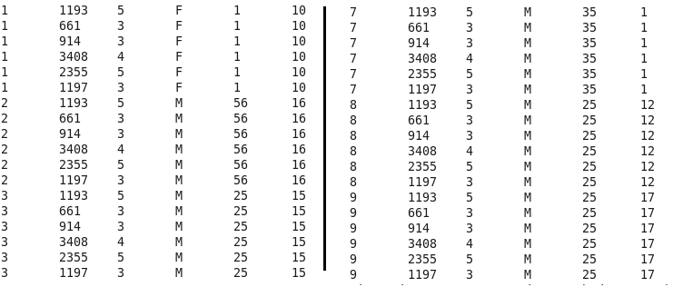

**Right -Outer Join with where clause in Gender:**

SELECT u.userid, r.movieid, r.rating, u.Gender, u.Age, u.Occupation FROM ratings_join r RIGHT OUTER JOIN user_join u ON r.userid = u.userid where u.Gender = "M";

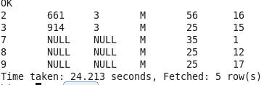

**Cartesian Join when used on specific user-id value returns same result:**

select r.userid, r.movieid, r.rating, u.Gender, u.Age, u.Occupation from ratings_join r join user_join u where r.userid = 3;

cartesian-join is different from inner-join, the latter join uses "ON" clause.

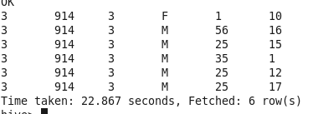

**Right -outer Join with ON:**

SELECT r.userid, r.movieid, r.rating, u.Gender, u.Age, u.Occupation FROM ratings_join r RIGHT OUTER JOIN user_join u ON r.userid = u.userid where u.userid = 3;

8.PNG

**Inner Join when used on specific user-id value returns same result:**

select r.userid, r.movieid, r.rating, u.Gender, u.Age, u.Occupation from ratings_join r join user_join u ON r.userid = u.userid where r.userid = 3;

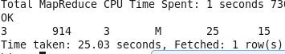

**No-Output: 9 userid is not a common variable**

select r.userid, r.movieid, r.rating, u.Gender, u.Age, u.Occupation FROM ratings_join r RIGHT OUTER JOIN user_join u ON r.userid = u.userid where r.userid = 9;

**Change the where clause checking predicate to get single row result:**

select r.userid, r.movieid, r.rating, u.Gender, u.Age, u.Occupation FROM ratings_join r RIGHT OUTER JOIN user_join u ON r.userid = u.userid where u.userid = 9;

**Can't change in this query because it performs an inner join which returns common rows:**

select r.userid, r.movieid, r.rating, u.Gender, u.Age, u.Occupation from ratings_join r join user_join u ON r.userid = u.userid where u.userid = 9;

**Performs Cartesian join and returns 6 rows while changing r.userid to u.userid in where clause:**

select r.userid, r.movieid, r.rating, u.Gender, u.Age, u.Occupation from ratings_join r join user_join u where u.userid = 9;